CS 340 README Template

About the Project/Project Title

Grazioso Salvare is an international rescue-animal training company who wants to find eligible dogs for search and rescue training. They have teamed up with a non-profit agency that will provide them with data about the dogs that the non-profit has available and may be suitable candidates for Grazioso Salvare’s cause. In order to make searching through the database containing all the records of the dogs easier, Global Rain’s development team has been tasked with creating a software application that can be used to find profiles of dogs that meet their criteria.

Motivation

With many records of dogs it can be difficult and less efficient to search through each individual record to find a dog profile that matches a certain criteria. This is where the software application will come into play to enable querying of the database to make looking for these matches more efficient and easier.

Getting Started

To get started, follow these steps:

- Clone the repo
- Open the terminal and use the command mongosh to enter the MongoDB shell
- Create the “aac” database
- Switch to the admin database and create a user with readwrite privileges for the aac database
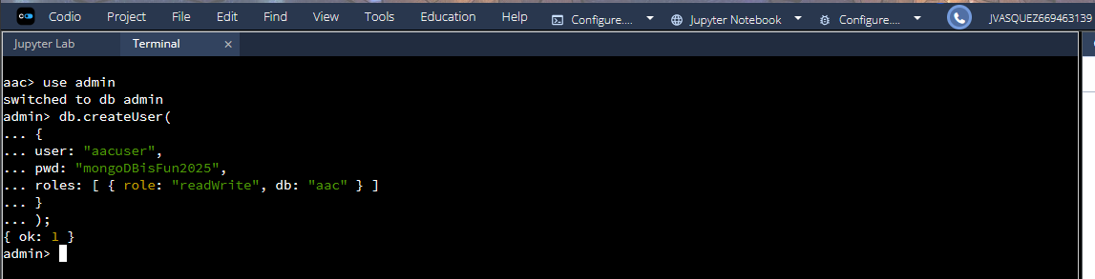
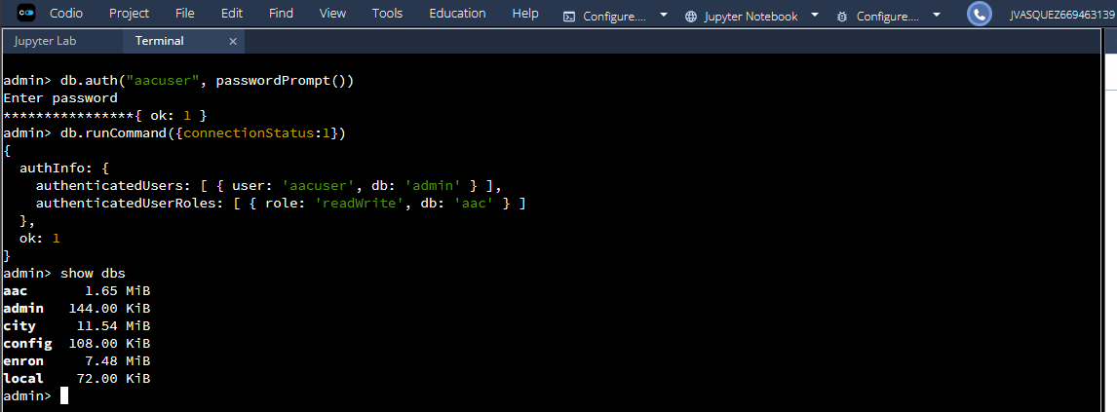
- Exit the MongoDB shell
- Use mongoimport to import the “aac_shelter_outcomes.csv” to the “aac” database:

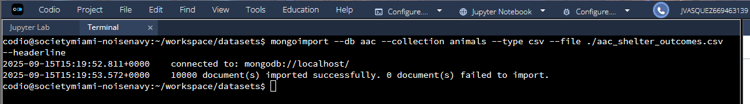

- Open the CRUD_Python_Module.py file and update the USER and PASS attributes of the AnimalShelter constructor to match your own user credentials.

Installation

The tools required are as followed:

- Python
- MongoDB
- IDE (e.g. VS code, Jupyter Notebook, Pycharm)
- Python Libraries: pyMongo

Visit the websites for Python and MongoDB to download each.

For installation of the pyMongo library, open a shell in terminal or command prompt and run the command:

python -m pip install pymongo

Usage

- Create import the CRUD_Python_Module and create an instance of the AnimalShelter class
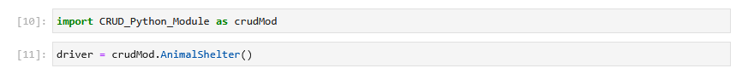

- To CREATE a new document, define the document as a dictionary and pass it in as an argument to the AnimalShelter instance’s create() method. The output should return true if the new document was successfully created and added to the collection.

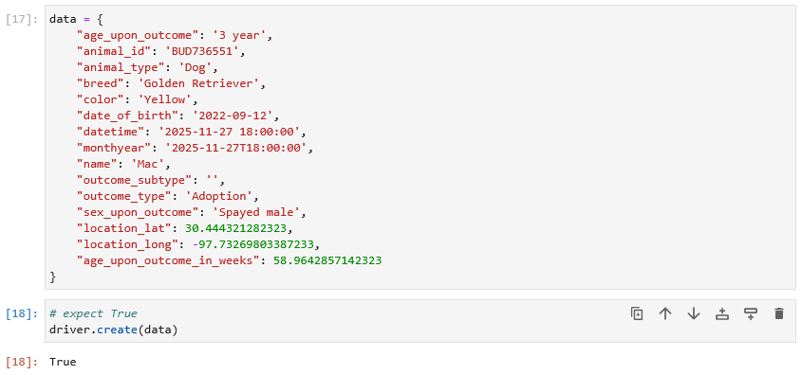

- To READ a document, build a query using a dictionary and pass it into the read() method.

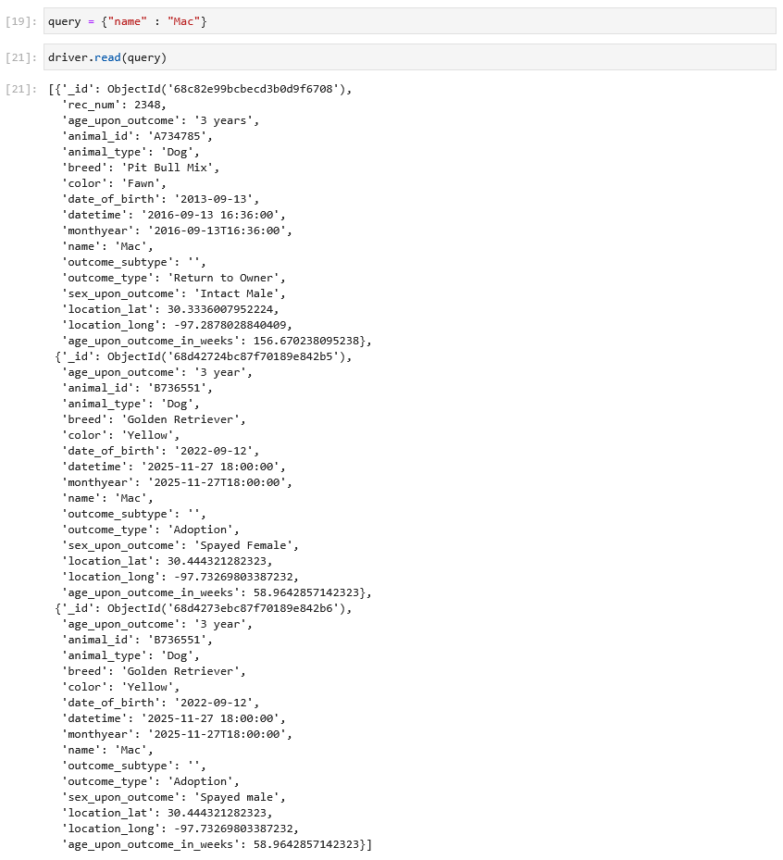

- To UPDATE a collection, pass two dictionaries where the first dictionary is the query and the second holds the changes that will be made. By default, the update method updates the first occurrence that matches the query. Change the “many” parameter to True to enable the update many functionality.

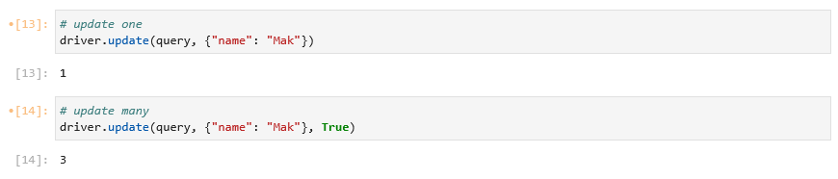

- To DELETE a collection, pass in a dictionary that acts as the query. By default, the delete method deletes the first occurrence that matches the query. Change the “many” parameter to True to enable the delete many functionality.

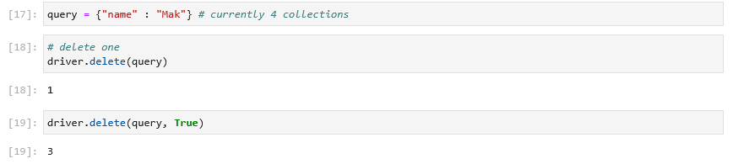

Roadmap/Features (Optional)

Contact

Jerry Vasquez

